PCA-SIMS Spectra Analysis Report

**High P (positive ions)**

ToF-SIMS testing date: 20230810

ToF-SIMS operator: Chris Pasture

# 2D PCA scores plots

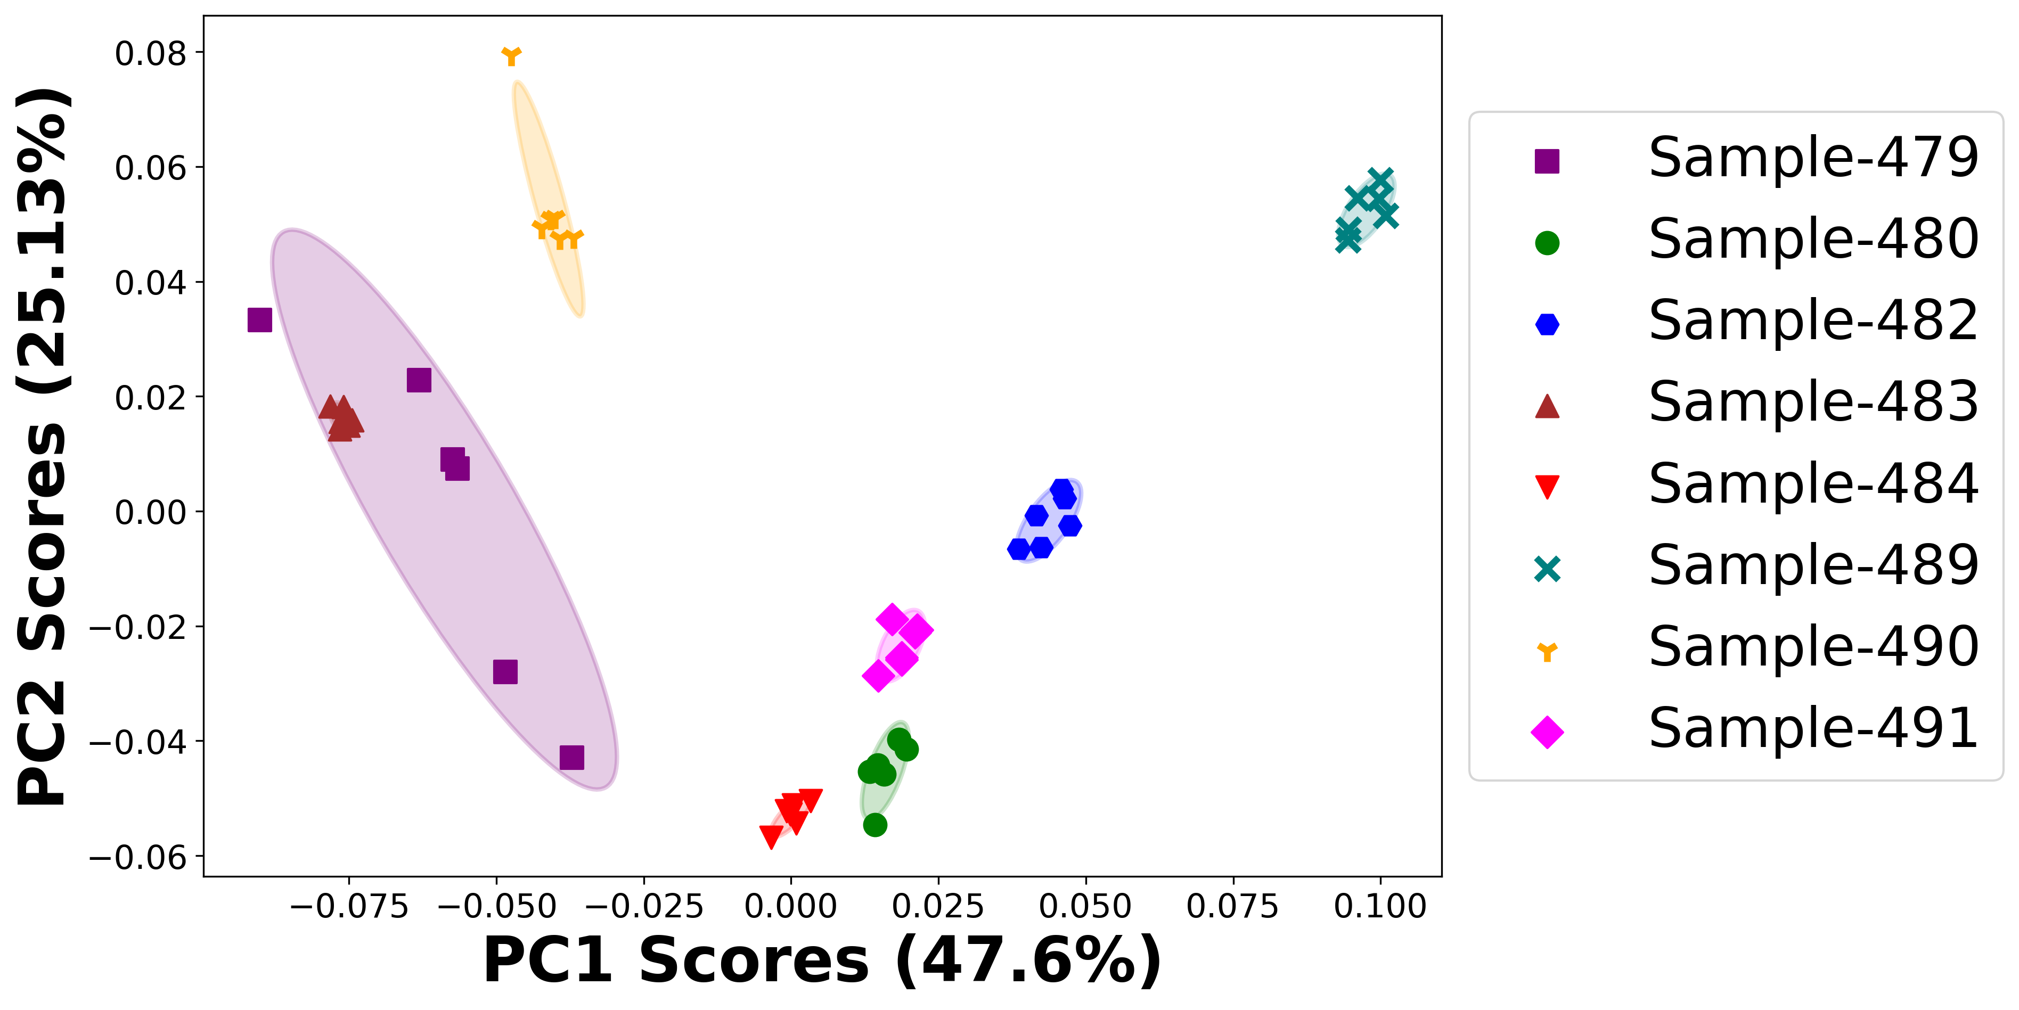

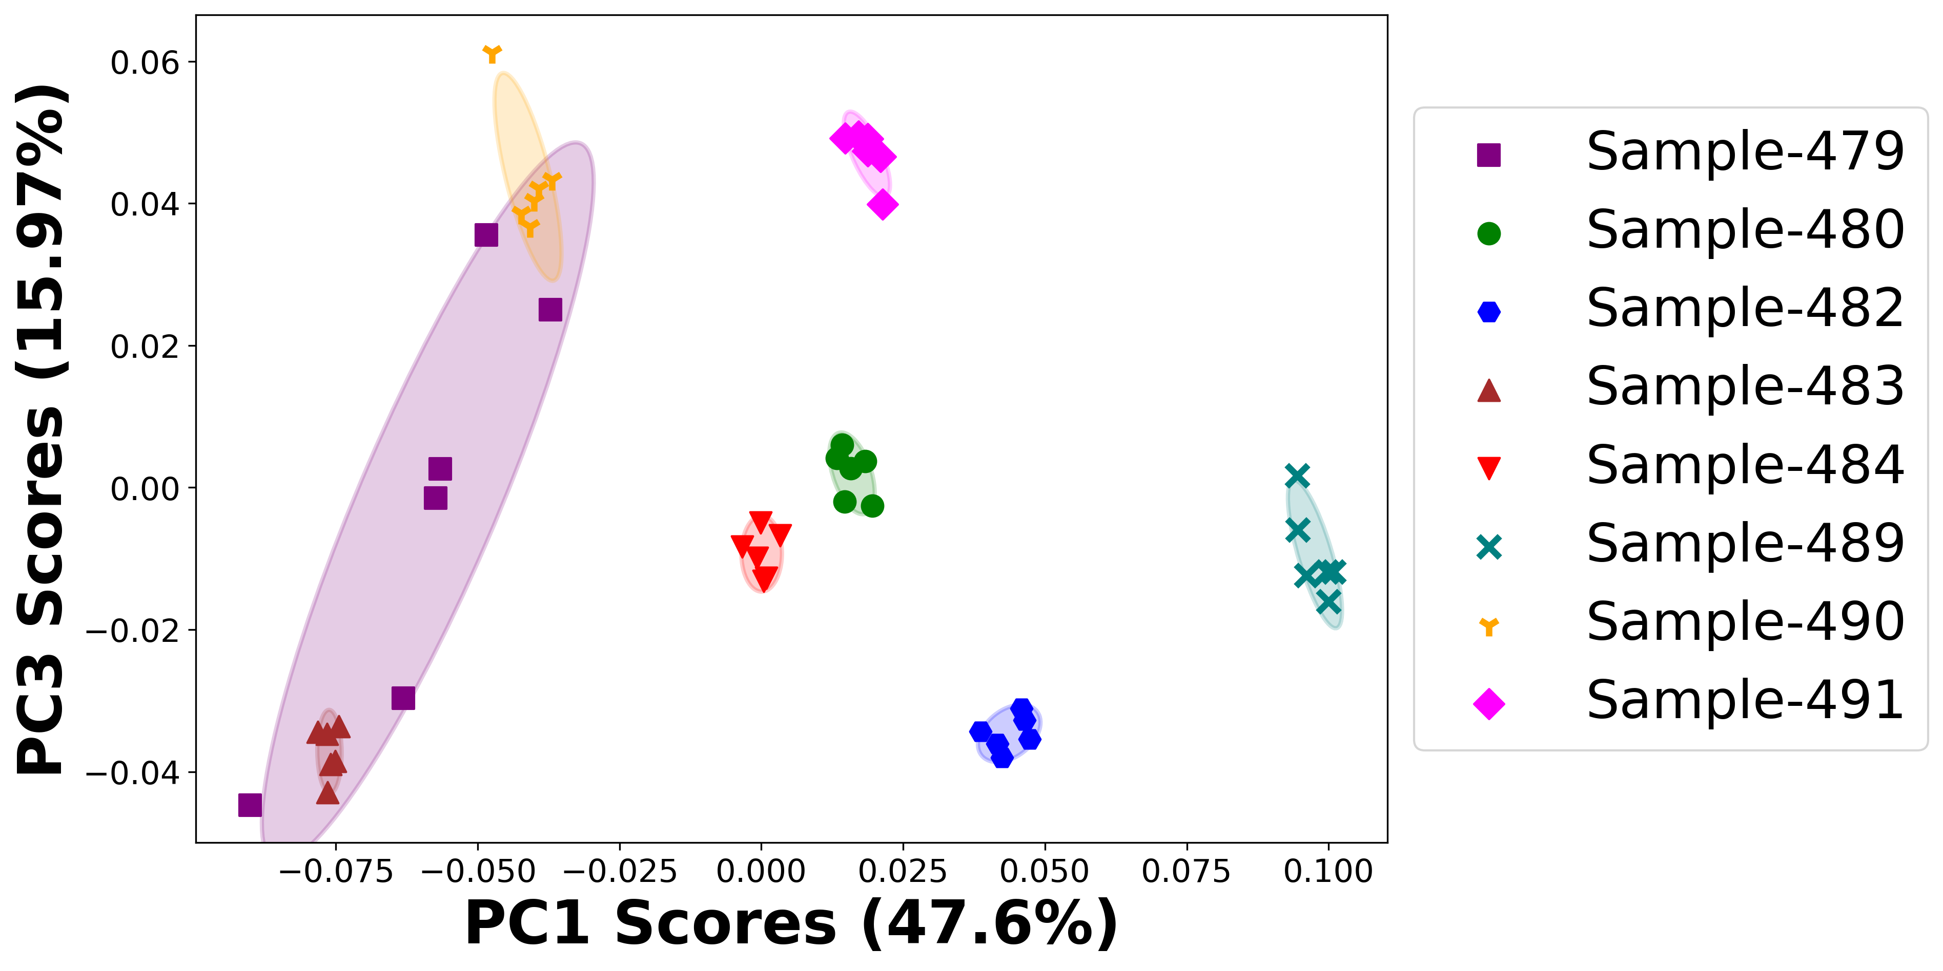

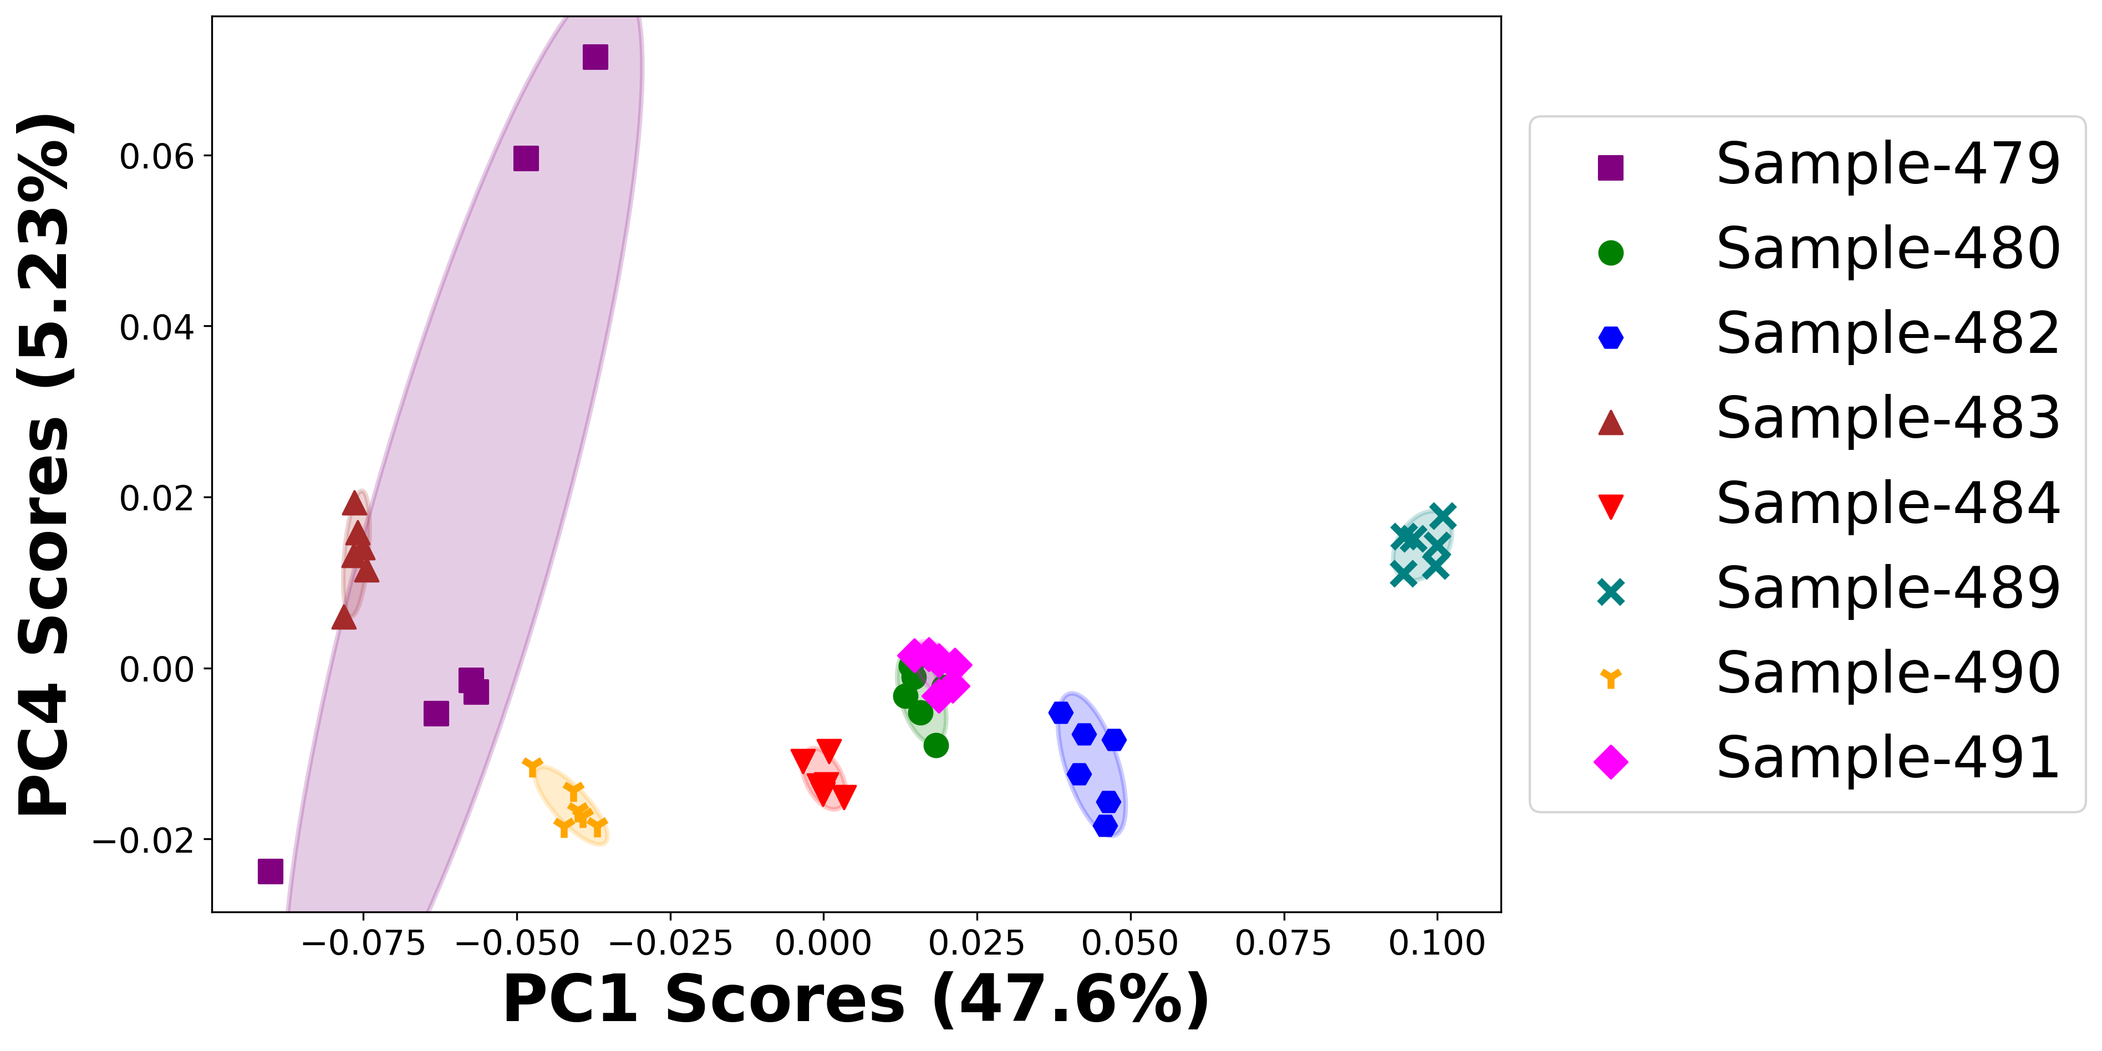

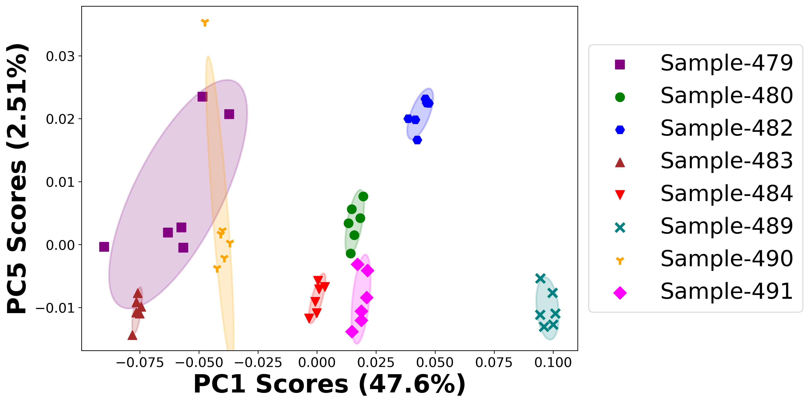

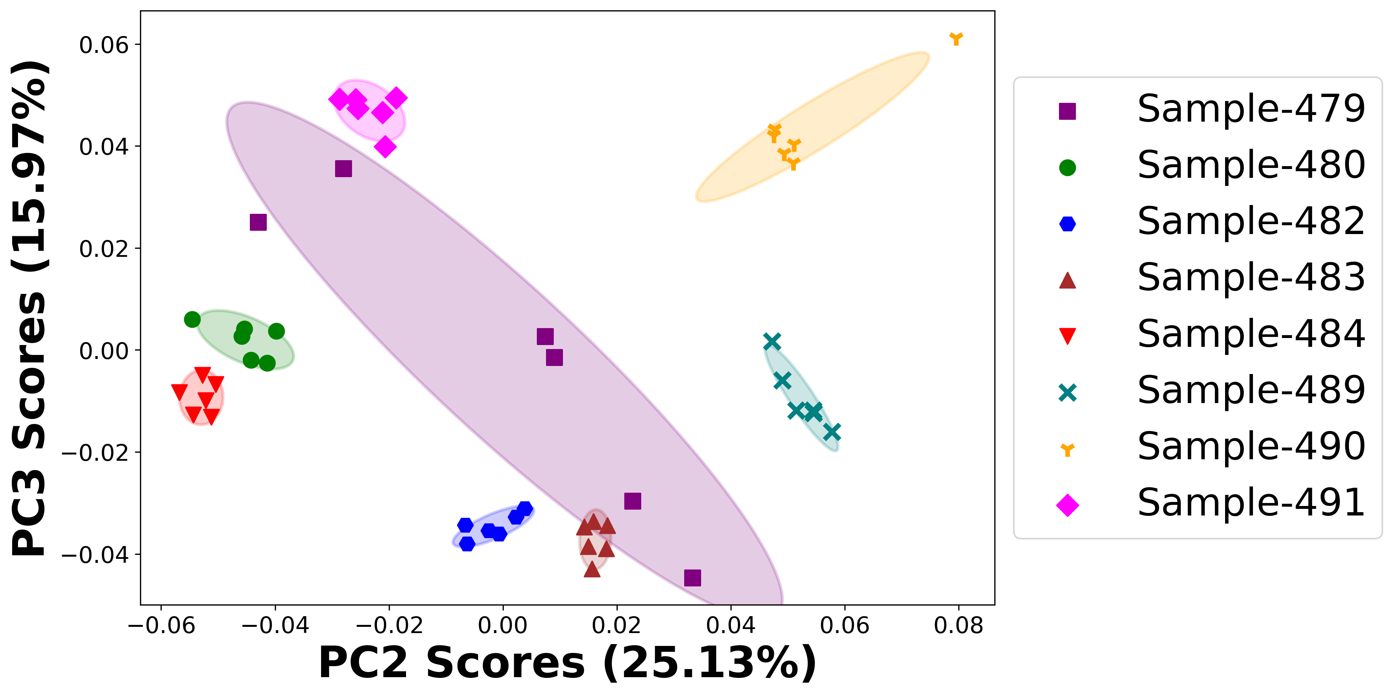

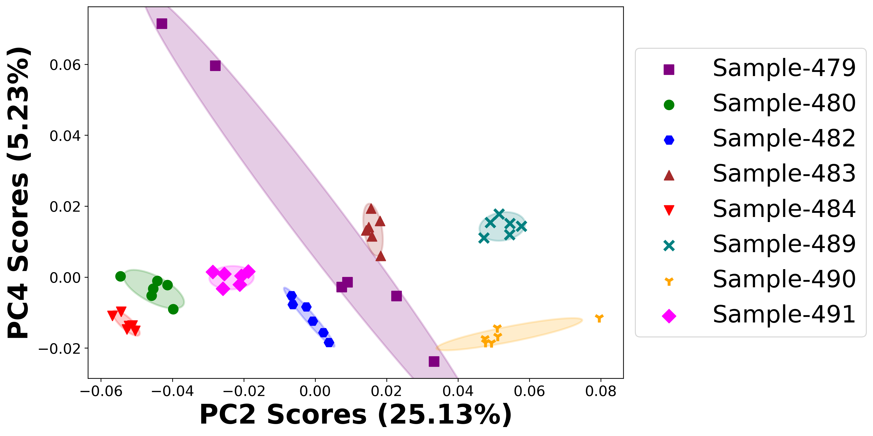

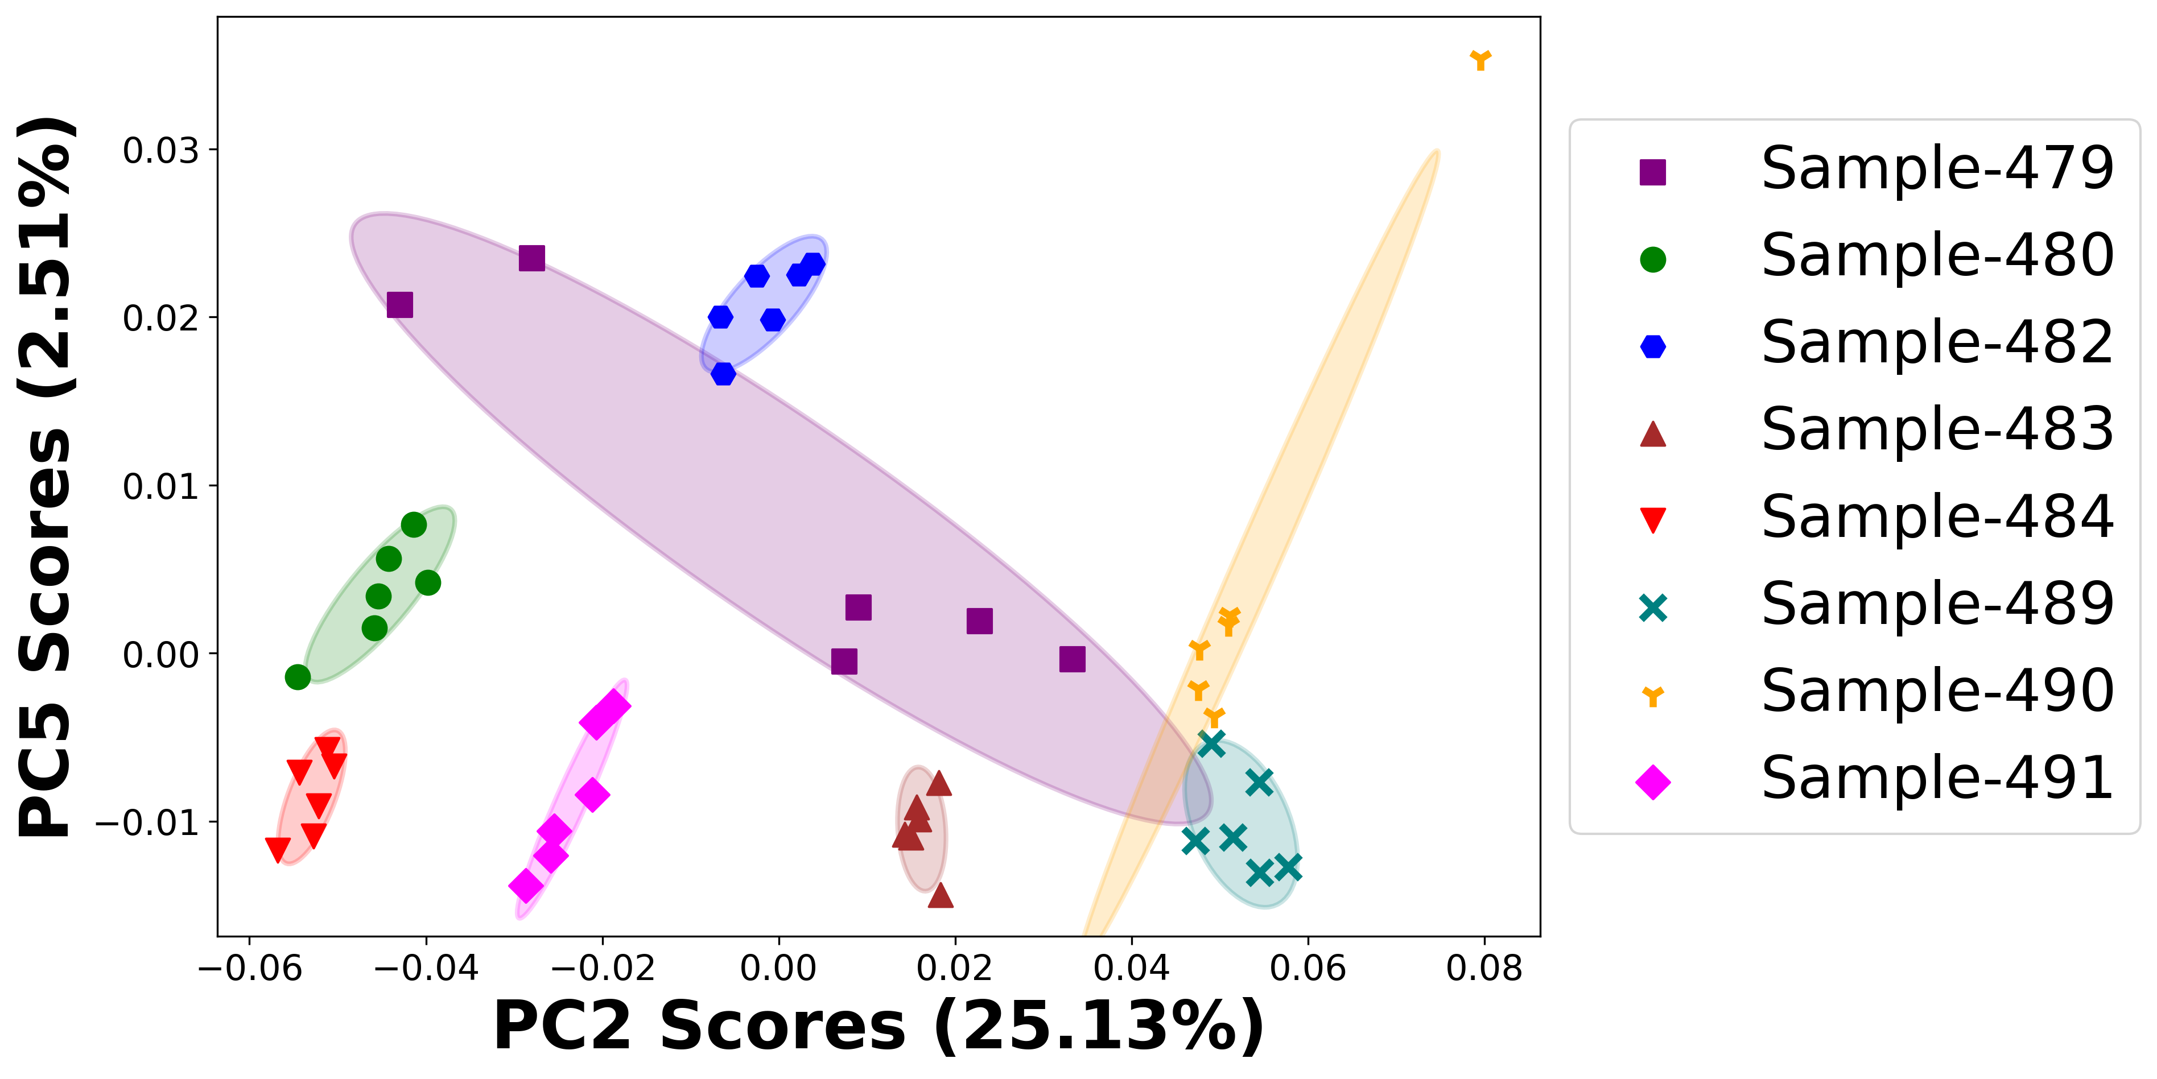

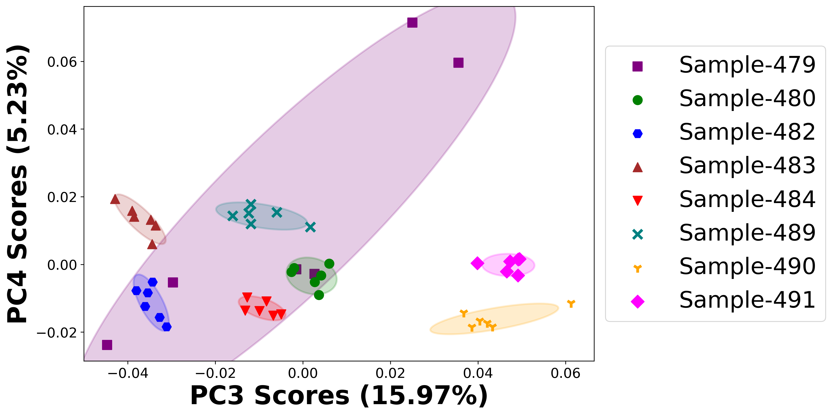

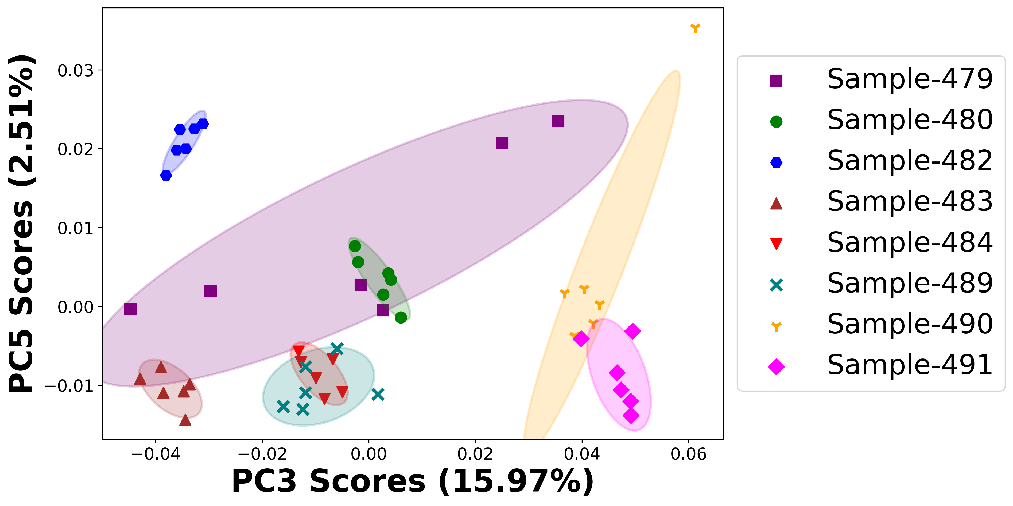

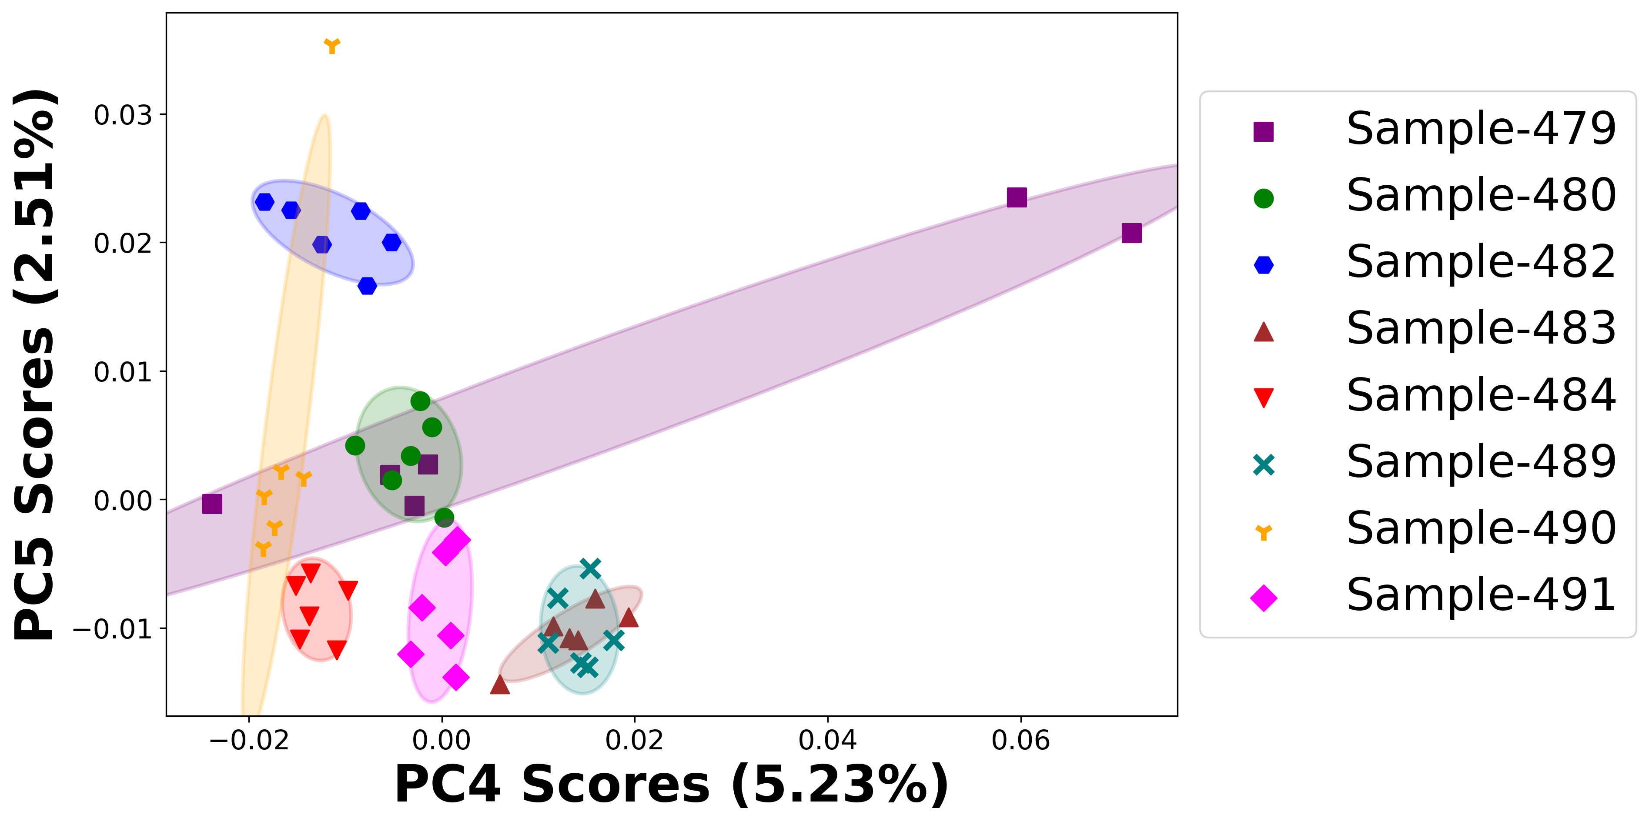

# Positive ion spectra, PCA analysis results -- PC1

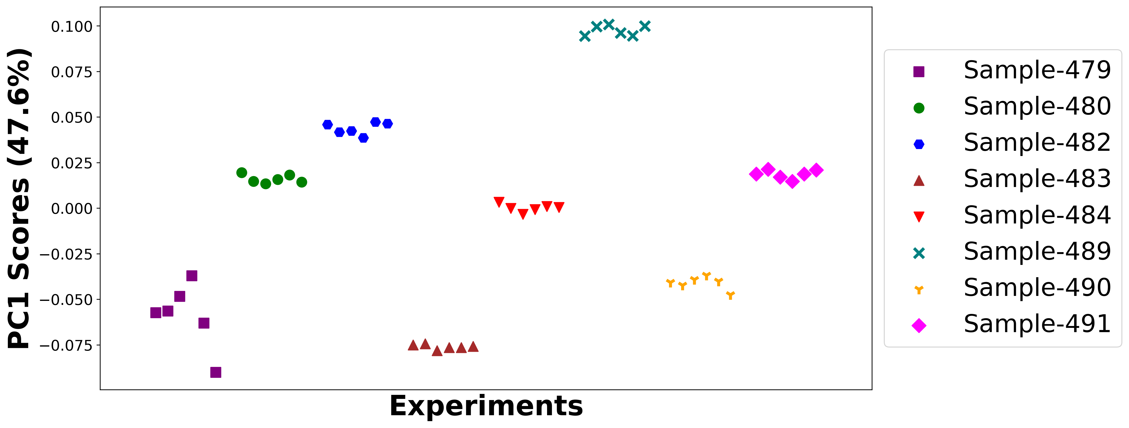

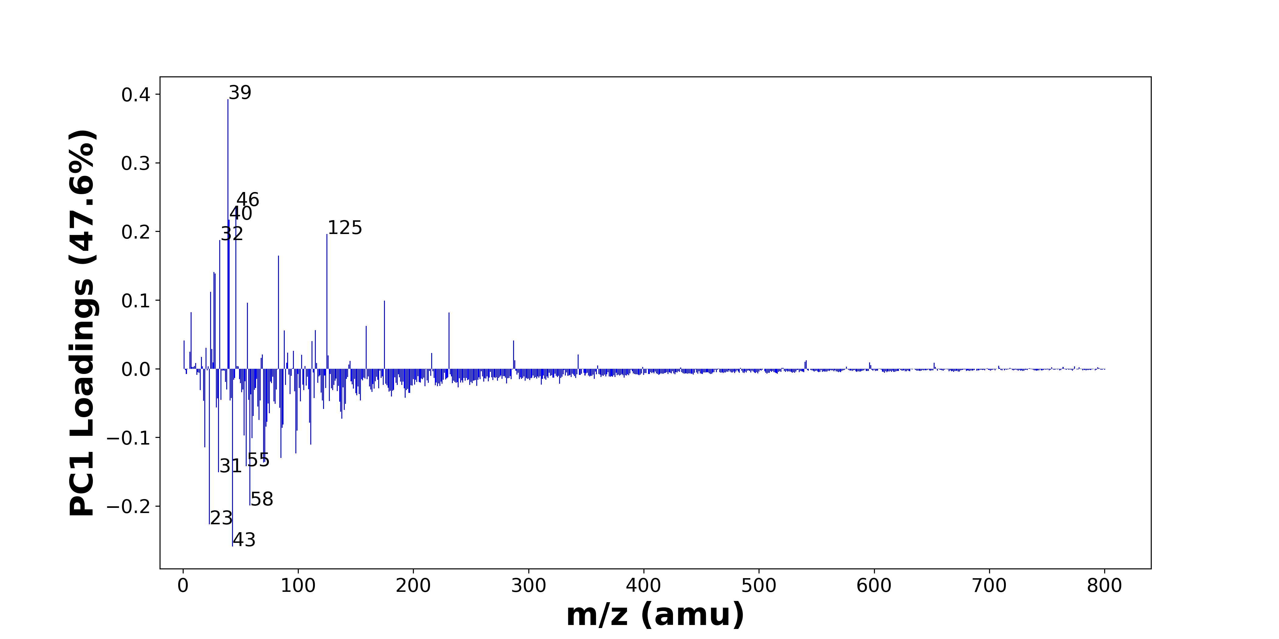

High score samples contain more:

* m/z 39 (K+), m/z 46 (C2H8N+, Na2+), m/z 40 (Ca+), m/z 125 (C8H15N+), m/z 32 (CH6N+), m/z 83 (C5H9N+), m/z 27 (Al+, C2H3+), m/z 28 (Si+), m/z 24 (Mg+), m/z 175 (Ca2PO4+), m/z 56 (56Fe+), m/z 7 (Li+), m/z 231 (Ca3PO5+), m/z 159 (C11H11O+), m/z 115 (C9H7+, CH5NFe+), m/z 88 (C4H10NO+), m/z 287 (), m/z 1 (H+), m/z 112 (Ca2O2+), m/z 20 (Ca++)

Low score samples contain more:

* m/z 43 (C2H3O+, C3H7+), m/z 23 (Na+), m/z 58 (C3H8N+), m/z 31 (OCH3+), m/z 55 (C4H7+), m/z 70 (C4H8N+), m/z 71 (C4H7O+), m/z 85 (Na3O+, NaSNO+), m/z 98 (), m/z 19 (OH3+), m/z 111 (?CH3SO4+), m/z 60 (C3H10N+), m/z 53 (C4H5+), m/z 99 (H3SO4+), m/z 86 (C5H12N+), m/z 72 (Si2O+, FeO+), m/z 87 (CH3OFe+), m/z 110 (), m/z 73 (FeOH+, SiC3H9+), m/z 66 (CaCN+)
* Hydrocarbons, Oxygen-containing organics, Nitrogen-containing organics

# Positive ion spectra, top positive loadings -- PC1

|  |  |  |  |  |  |  |  |  |
| --- | --- | --- | --- | --- | --- | --- | --- | --- |
| + Loading No. | Unit Mass | Document Mass | Initial Peak Assignment | Initial Probabilities | Measured Mass | Peak Assignment (Qualified) | Updated Peak Assignment (from Document Mass) | Updated Document Mass |
| 1 | 39 | 38.9632 | K+ | 1.0 |  |  |  |  |
| 2 | 46 | 46.0652 45.979 | C2H8N+ Na2+ | 0.972 0.028 |  |  |  |  |
| 3 | 40 | 39.962 | Ca+ | 1.0 | 39.9625 | Ca+ |  |  |
| 4 | 125 | 125.1199 | C8H15N+ | 1.0 | 125.13 | C8H15N+ |  |  |
| 5 | 32 | 32.0645 | CH6N+ | 1.0 | 32.0595 | CH6N+ |  |  |
| 6 | 83 | 83.073 | C5H9N+ | 1.0 | 83.0629 | C5H9N+ |  |  |
| 7 | 27 | 26.981 27.023 | Al+ C2H3+ | 0.702 0.298 |  |  |  |  |
| 8 | 28 | 27.9764 | Si+ | 1.0 |  |  |  |  |
| 9 | 24 | 23.9845 | Mg+ | 1.0 |  |  |  |  |
| 10 | 175 | 174.8781 | Ca2PO4+ | 1.0 |  |  |  |  |
| 11 | 56 | 55.9344 | 56Fe+ | 0.998 |  |  |  |  |
| 12 | 7 | 7.0155 | Li+ | 1.0 |  |  |  |  |
| 13 | 231 | 230.8356 | Ca3PO5+ | 1.0 |  |  |  |  |
| 14 | 159 | 159.0804 | C11H11O+ | 1.0 |  |  |  |  |
| 15 | 115 | 115.0543 114.9174 | C9H7+ CH5NFe+ | 0.877 0.123 |  |  |  |  |
| 16 | 88 | 88.0757 | C4H10NO+ | 1.0 |  |  |  |  |
| 17 | 287 |  |  |  |  |  |  |  |
| 18 | 1 | 1.0073 | H+ | 1.0 |  |  |  |  |
| 19 | 112 | 111.9145 | Ca2O2+ | 1.0 |  |  |  |  |
| 20 | 20 | 19.9807 | Ca++ | 1.0 |  |  |  |  |

# Positive ion spectra, top negative loadings -- PC1

|  |  |  |  |  |  |  |  |  |
| --- | --- | --- | --- | --- | --- | --- | --- | --- |
| - Loading No. | Unit Mass | Document Mass | Initial Peak Assignment | Initial Probabilities | Measured Mass | Peak Assignment (Qualified) | Updated Peak Assignment (from Document Mass) | Updated Document Mass |
| 1 | 43 | 43.0178 43.0543 | C2H3O+ C3H7+ | 0.533 0.467 |  |  |  |  |
| 2 | 23 | 22.9892 | Na+ | 1.0 | 22.98 | Na+ |  |  |
| 3 | 58 | 58.0651 | C3H8N+ | 1.0 |  |  |  |  |
| 4 | 31 | 31.0179 | OCH3+ | 1.0 |  |  |  |  |
| 5 | 55 | 55.0543 | C4H7+ | 1.0 |  |  |  |  |
| 6 | 70 | 70.0652 | C4H8N+ | 1.0 |  |  |  |  |
| 7 | 71 | 71.0496 | C4H7O+ | 1.0 |  |  |  |  |
| 8 | 85 | 84.9637 84.9593 | Na3O+ NaSNO+ | 0.529 0.471 |  |  |  |  |
| 9 | 98 |  |  |  |  |  |  |  |
| 10 | 19 | 19.0179 | OH3+ | 1.0 |  |  |  |  |
| 11 | 111 | 110.9747 | ?CH3SO4+ | 1.0 | 110.97 | ?CH3SO4+ |  |  |
| 12 | 60 | 60.0808 | C3H10N+ | 1.0 |  |  |  |  |
| 13 | 53 | 53.0386 | C4H5+ | 1.0 |  |  |  |  |
| 14 | 99 | 98.9747 | H3SO4+ | 1.0 |  |  |  |  |
| 15 | 86 | 86.0965 | C5H12N+ | 1.0 |  |  |  |  |
| 16 | 72 | 71.9482 71.9293 | Si2O+ FeO+ | 0.594 0.313 |  |  |  |  |
| 17 | 87 | 86.9528 | CH3OFe+ | 1.0 |  |  |  |  |
| 18 | 110 |  |  |  |  |  |  |  |
| 19 | 73 | 72.9371 73.0469 | FeOH+ SiC3H9+ | 0.972 0.028 | 72.94 | FeOH+ SiC3H9+ |  |  |
| 20 | 66 | 65.9651 | CaCN+ | 1.0 |  |  |  |  |

# Positive ion spectra, molecular information from PC1 loadings plot

* The major positive PC1 loadings are m/z 39 (K+), m/z 46 (C2H8N+, Na2+), m/z 40 (Ca+), m/z 125 (C8H15N+), m/z 32 (CH6N+), m/z 83 (C5H9N+), m/z 27 (Al+, C2H3+), m/z 28 (Si+), m/z 24 (Mg+), m/z 175 (Ca2PO4+), m/z 56 (56Fe+), m/z 7 (Li+), m/z 231 (Ca3PO5+), m/z 159 (C11H11O+), m/z 115 (C9H7+, CH5NFe+), m/z 88 (C4H10NO+), m/z 287 (), m/z 1 (H+), m/z 112 (Ca2O2+), m/z 20 (Ca++), indicating they are more observed in high PC1 score samples.
* The major negative PC1 loadings are m/z 43 (C2H3O+, C3H7+), m/z 23 (Na+), m/z 58 (C3H8N+), m/z 31 (OCH3+), m/z 55 (C4H7+), m/z 70 (C4H8N+), m/z 71 (C4H7O+), m/z 85 (Na3O+, NaSNO+), m/z 98 (), m/z 19 (OH3+), m/z 111 (?CH3SO4+), m/z 60 (C3H10N+), m/z 53 (C4H5+), m/z 99 (H3SO4+), m/z 86 (C5H12N+), m/z 72 (Si2O+, FeO+), m/z 87 (CH3OFe+), m/z 110 (), m/z 73 (FeOH+, SiC3H9+), m/z 66 (CaCN+), indicating they are more observed in low PC1 score samples.
* Hydrocarbons signals, such as m/z 43 (C2H3O+, C3H7+), m/z 55 (C4H7+), are mostly found in negative loadings, indicating that low PC1 score samples contain more Hydrocarbons.
* Oxygen-containing organics signals, such as m/z 31 (OCH3+), m/z 19 (OH3+), are mostly found in negative loadings, indicating that low PC1 score samples contain more Oxygen-containing organics.
* Nitrogen-containing organics signals, such as m/z 70 (C4H8N+), m/z 86 (C5H12N+), are mostly found in negative loadings, indicating that low PC1 score samples contain more Nitrogen-containing organics.

# Positive ion spectra, PCA analysis results -- PC2

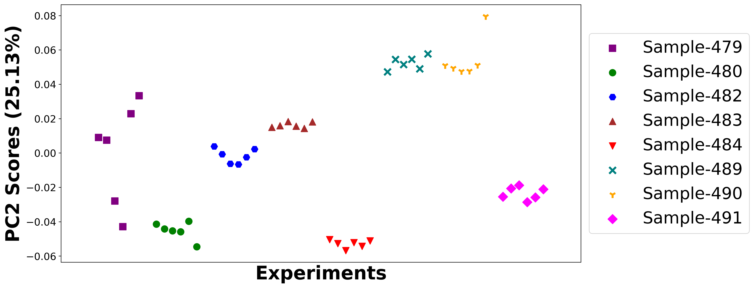

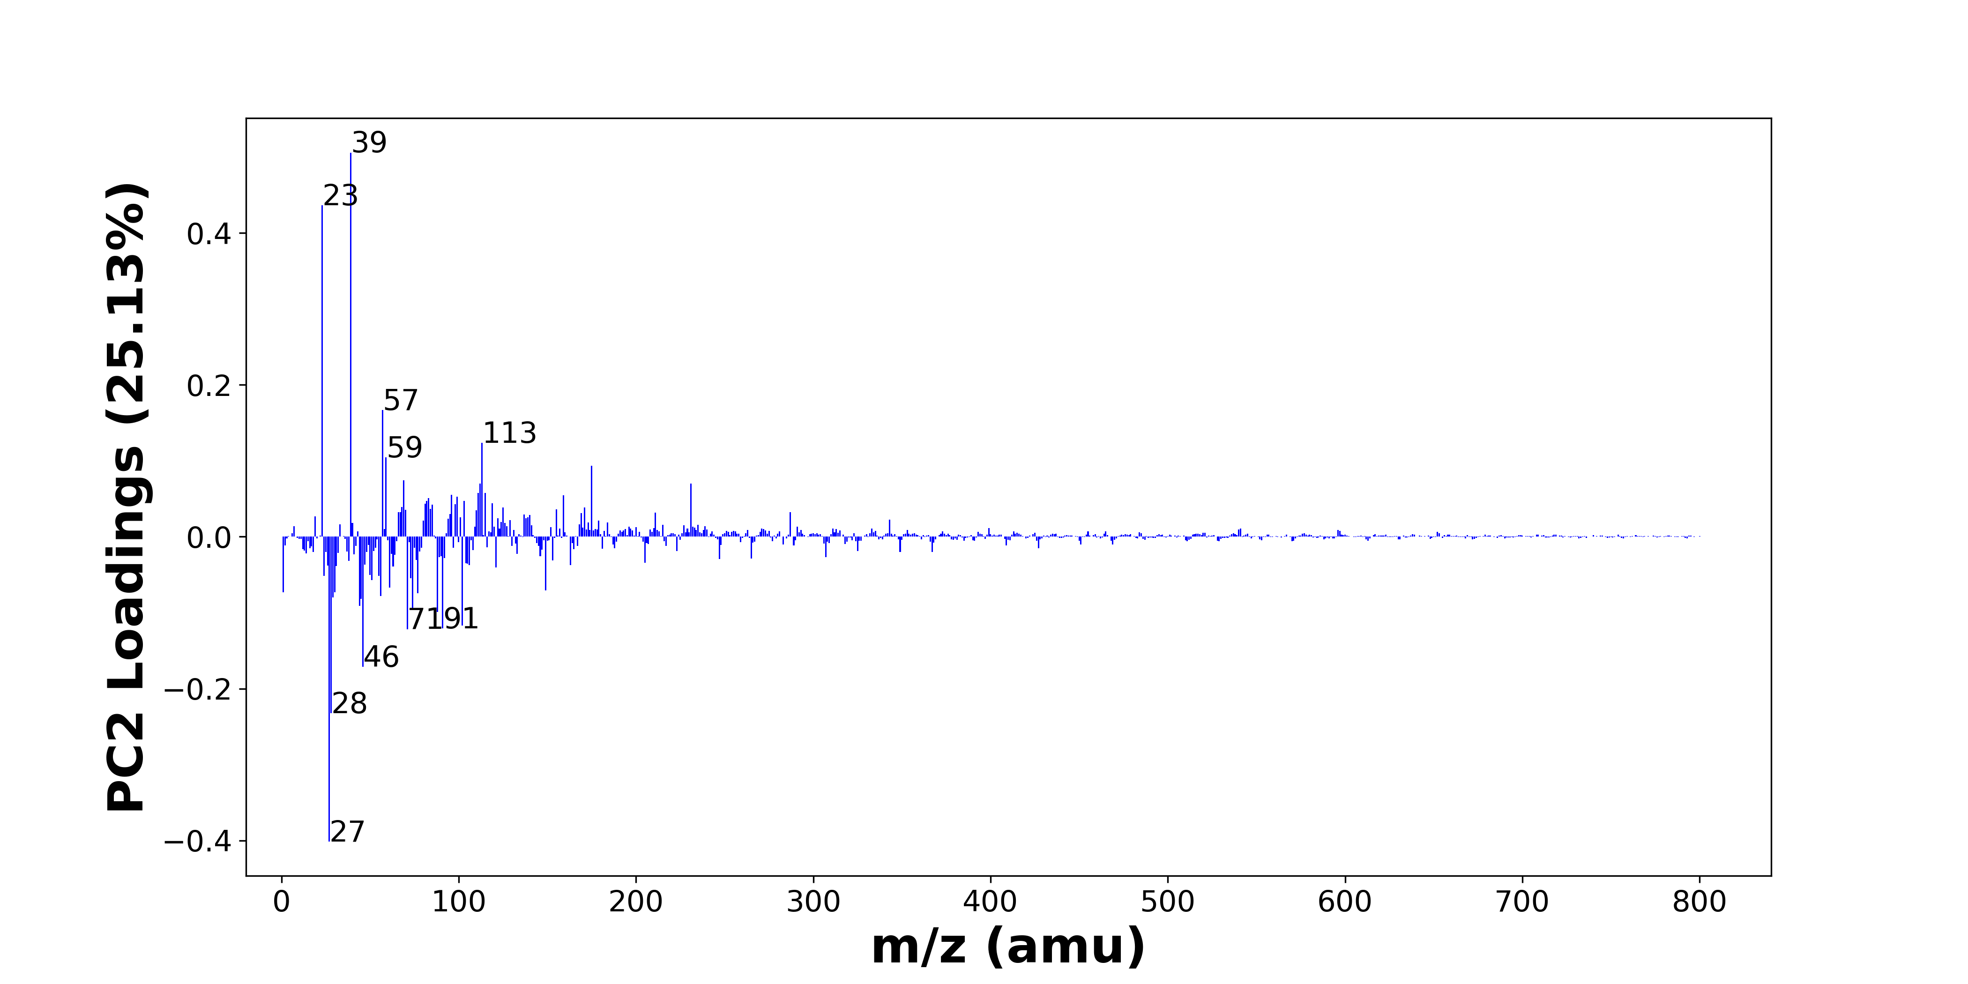

High score samples contain more:

* m/z 39 (K+), m/z 23 (Na+), m/z 57 (CaOH+, C4H9+), m/z 113 (), m/z 59 (), m/z 175 (Ca2PO4+), m/z 69 (), m/z 231 (Ca3PO5+), m/z 112 (Ca2O2+), m/z 115 (C9H7+, CH5NFe+), m/z 111 (?CH3SO4+), m/z 96 (), m/z 159 (C11H11O+), m/z 99 (H3SO4+), m/z 83 (C5H9N+), m/z 82 (), m/z 103 (), m/z 119 (), m/z 81 (), m/z 98 ()

Low score samples contain more:

* m/z 27 (Al+, C2H3+), m/z 28 (Si+), m/z 46 (C2H8N+, Na2+), m/z 71 (C4H7O+), m/z 91 (C7H7+), m/z 102 (), m/z 88 (C4H10NO+), m/z 74 (), m/z 44 (C2H6N+), m/z 45 (SiOH+, C2H5O+), m/z 29 (C2H5+, 29Si+), m/z 56 (56Fe+), m/z 77 (C6H5+), m/z 1 (H+), m/z 30 (CH4N+, 30Si+), m/z 149 (), m/z 61 (), m/z 51 (), m/z 73 (FeOH+, SiC3H9+), m/z 24 (Mg+)
* Hydrocarbons, Nitrogen-containing organics, Benzene-containing organics

# Positive ion spectra, top positive loadings -- PC2

|  |  |  |  |  |  |  |  |  |
| --- | --- | --- | --- | --- | --- | --- | --- | --- |
| + Loading No. | Unit Mass | Document Mass | Initial Peak Assignment | Initial Probabilities | Measured Mass | Peak Assignment (Qualified) | Updated Peak Assignment (from Document Mass) | Updated Document Mass |
| 1 | 39 | 38.9632 | K+ | 1.0 |  |  |  |  |
| 2 | 23 | 22.9892 | Na+ | 1.0 | 22.98 | Na+ |  |  |
| 3 | 57 | 56.9648 57.0699 | CaOH+ C4H9+ | 0.976 0.024 |  |  |  |  |
| 4 | 113 |  |  |  |  |  |  |  |
| 5 | 59 |  |  |  |  |  |  |  |
| 6 | 175 | 174.8781 | Ca2PO4+ | 1.0 |  |  |  |  |
| 7 | 69 |  |  |  |  |  |  |  |
| 8 | 231 | 230.8356 | Ca3PO5+ | 1.0 |  |  |  |  |
| 9 | 112 | 111.9145 | Ca2O2+ | 1.0 |  |  |  |  |
| 10 | 115 | 115.0543 114.9174 | C9H7+ CH5NFe+ | 0.877 0.123 |  |  |  |  |
| 11 | 111 | 110.9747 | ?CH3SO4+ | 1.0 | 110.97 | ?CH3SO4+ |  |  |
| 12 | 96 |  |  |  |  |  |  |  |
| 13 | 159 | 159.0804 | C11H11O+ | 1.0 |  |  |  |  |
| 14 | 99 | 98.9747 | H3SO4+ | 1.0 |  |  |  |  |
| 15 | 83 | 83.073 | C5H9N+ | 1.0 | 83.0629 | C5H9N+ |  |  |
| 16 | 82 |  |  |  |  |  |  |  |
| 17 | 103 |  |  |  |  |  |  |  |
| 18 | 119 |  |  |  |  |  |  |  |
| 19 | 81 |  |  |  |  |  |  |  |
| 20 | 98 |  |  |  |  |  |  |  |

# Positive ion spectra, top negative loadings -- PC2

|  |  |  |  |  |  |  |  |  |
| --- | --- | --- | --- | --- | --- | --- | --- | --- |
| - Loading No. | Unit Mass | Document Mass | Initial Peak Assignment | Initial Probabilities | Measured Mass | Peak Assignment (Qualified) | Updated Peak Assignment (from Document Mass) | Updated Document Mass |
| 1 | 27 | 26.981 27.023 | Al+ C2H3+ | 0.702 0.298 |  |  |  |  |
| 2 | 28 | 27.9764 | Si+ | 1.0 |  |  |  |  |
| 3 | 46 | 46.0652 45.979 | C2H8N+ Na2+ | 0.972 0.028 |  |  |  |  |
| 4 | 71 | 71.0496 | C4H7O+ | 1.0 |  |  |  |  |
| 5 | 91 | 91.0543 | C7H7+ | 1.0 |  |  |  |  |
| 6 | 102 |  |  |  |  |  |  |  |
| 7 | 88 | 88.0757 | C4H10NO+ | 1.0 |  |  |  |  |
| 8 | 74 |  |  |  |  |  |  |  |
| 9 | 44 | 44.0495 | C2H6N+ | 1.0 |  |  |  |  |
| 10 | 45 | 44.9792 45.0335 | SiOH+ C2H5O+ | 0.761 0.239 |  |  |  |  |
| 11 | 29 | 29.0386 28.9759 | C2H5+ 29Si+ | 0.894 0.106 |  |  |  |  |
| 12 | 56 | 55.9344 | 56Fe+ | 0.998 |  |  |  |  |
| 13 | 77 | 77.0386 | C6H5+ | 1.0 |  |  |  |  |
| 14 | 1 | 1.0073 | H+ | 1.0 |  |  |  |  |
| 15 | 30 | 30.0339 29.9732 | CH4N+ 30Si+ | 0.891 0.109 |  |  |  |  |
| 16 | 149 |  |  |  |  |  |  |  |
| 17 | 61 |  |  |  |  |  |  |  |
| 18 | 51 |  |  |  |  |  |  |  |
| 19 | 73 | 72.9371 73.0469 | FeOH+ SiC3H9+ | 0.972 0.028 | 72.94 | FeOH+ SiC3H9+ |  |  |
| 20 | 24 | 23.9845 | Mg+ | 1.0 |  |  |  |  |

# Positive ion spectra, molecular information from PC2 loadings plot

* The major positive PC2 loadings are m/z 39 (K+), m/z 23 (Na+), m/z 57 (CaOH+, C4H9+), m/z 113 (), m/z 59 (), m/z 175 (Ca2PO4+), m/z 69 (), m/z 231 (Ca3PO5+), m/z 112 (Ca2O2+), m/z 115 (C9H7+, CH5NFe+), m/z 111 (?CH3SO4+), m/z 96 (), m/z 159 (C11H11O+), m/z 99 (H3SO4+), m/z 83 (C5H9N+), m/z 82 (), m/z 103 (), m/z 119 (), m/z 81 (), m/z 98 (), indicating they are more observed in high PC2 score samples.
* The major negative PC2 loadings are m/z 27 (Al+, C2H3+), m/z 28 (Si+), m/z 46 (C2H8N+, Na2+), m/z 71 (C4H7O+), m/z 91 (C7H7+), m/z 102 (), m/z 88 (C4H10NO+), m/z 74 (), m/z 44 (C2H6N+), m/z 45 (SiOH+, C2H5O+), m/z 29 (C2H5+, 29Si+), m/z 56 (56Fe+), m/z 77 (C6H5+), m/z 1 (H+), m/z 30 (CH4N+, 30Si+), m/z 149 (), m/z 61 (), m/z 51 (), m/z 73 (FeOH+, SiC3H9+), m/z 24 (Mg+), indicating they are more observed in low PC2 score samples.
* Hydrocarbons signals, such as m/z 27 (Al+, C2H3+), m/z 29 (C2H5+, 29Si+), are mostly found in negative loadings, indicating that low PC2 score samples contain more Hydrocarbons.
* Nitrogen-containing organics signals, such as m/z 30 (CH4N+, 30Si+), m/z 44 (C2H6N+), are mostly found in negative loadings, indicating that low PC2 score samples contain more Nitrogen-containing organics.
* Benzene-containing organics signals, such as m/z 91 (C7H7+), m/z 77 (C6H5+), are mostly found in negative loadings, indicating that low PC2 score samples contain more Benzene-containing organics.

# Positive ion spectra, PCA analysis results -- PC3

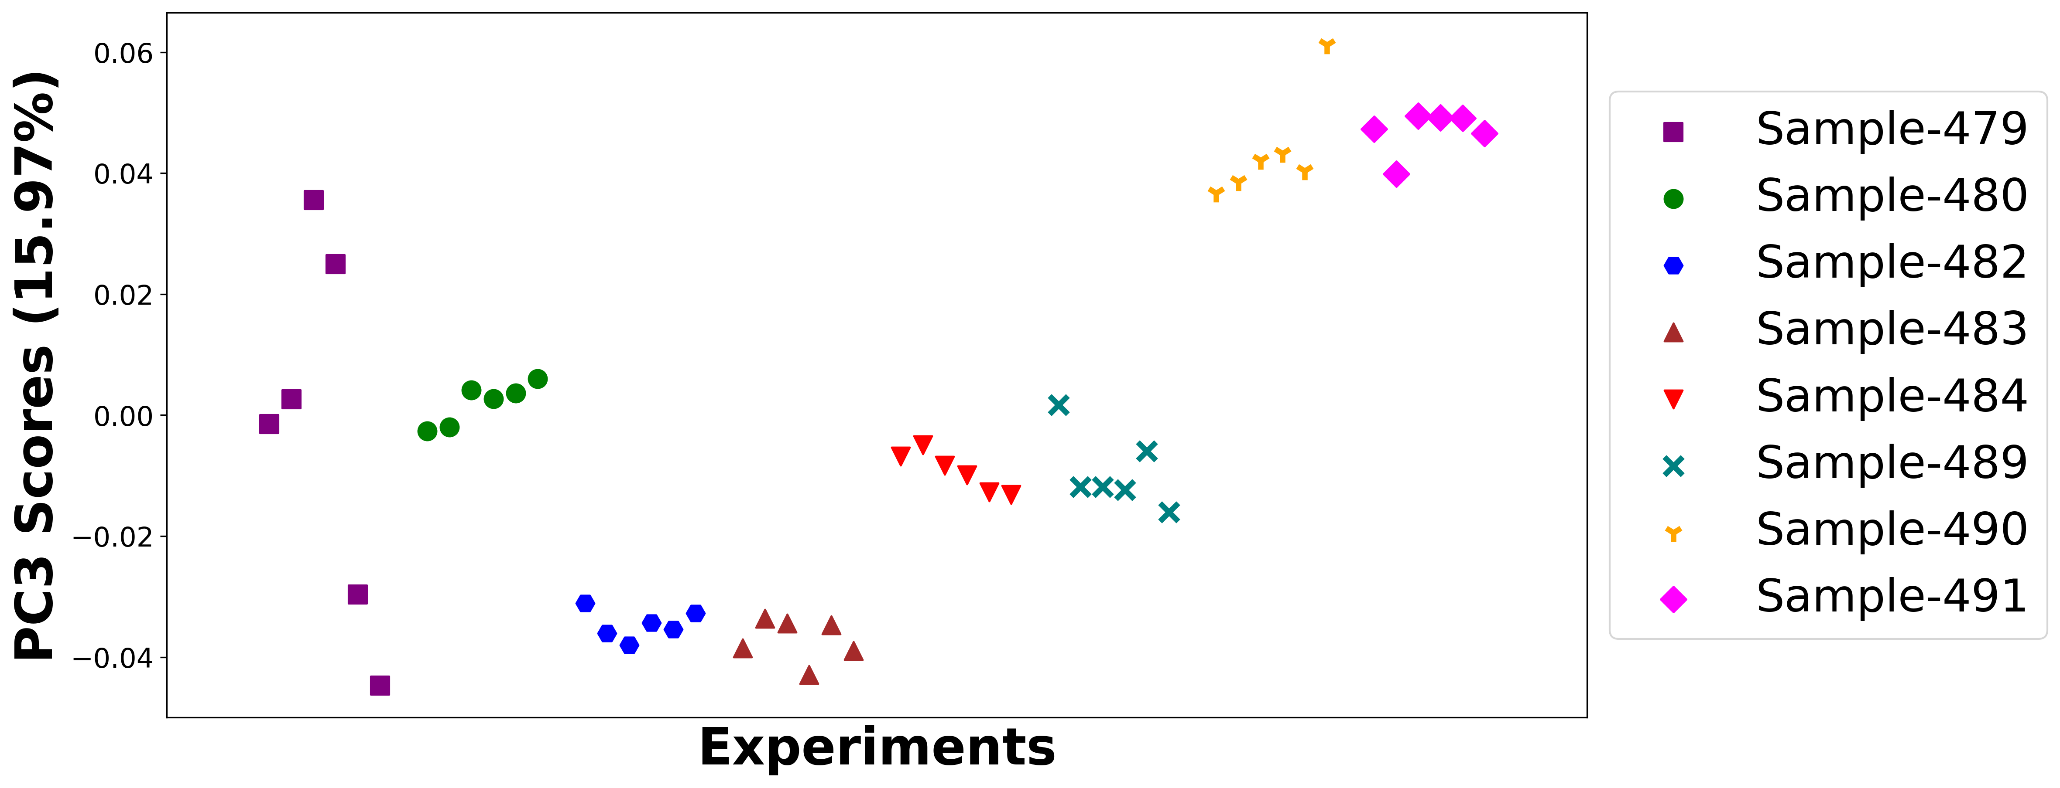

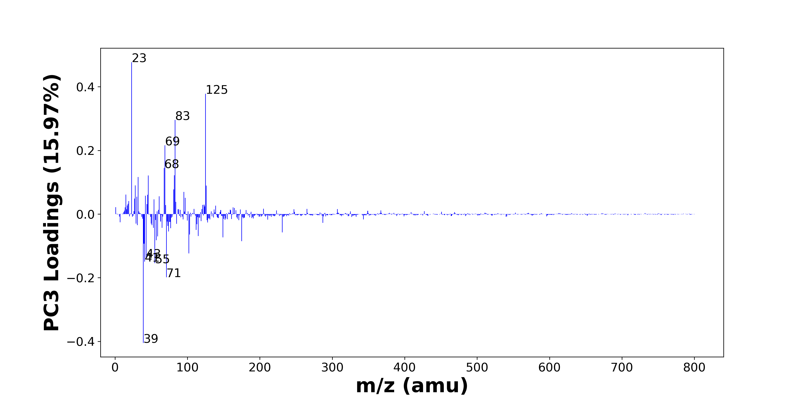

High score samples contain more:

* m/z 23 (Na+), m/z 125 (C8H15N+), m/z 83 (C5H9N+), m/z 69 (), m/z 68 (), m/z 82 (), m/z 46 (C2H8N+, Na2+), m/z 32 (CH6N+), m/z 28 (Si+), m/z 126 (), m/z 81 (), m/z 95 (), m/z 15 (CH3+), m/z 45 (SiOH+, C2H5O+), m/z 42 (), m/z 61 (), m/z 30 (CH4N+, 30Si+), m/z 97 (), m/z 27 (Al+, C2H3+), m/z 54 ()
* Hydrocarbons, Nitrogen-containing organics

Low score samples contain more:

* m/z 39 (K+), m/z 71 (C4H7O+), m/z 55 (C4H7+), m/z 41 (C3H5+, 41K+), m/z 43 (C2H3O+, C3H7+), m/z 102 (), m/z 40 (Ca+), m/z 175 (Ca2PO4+), m/z 57 (CaOH+, C4H9+), m/z 149 (), m/z 59 (), m/z 115 (C9H7+, CH5NFe+), m/z 103 (), m/z 231 (Ca3PO5+), m/z 74 (), m/z 112 (Ca2O2+), m/z 77 (C6H5+), m/z 53 (C4H5+), m/z 65 (), m/z 73 (FeOH+, SiC3H9+)

# Positive ion spectra, top positive loadings -- PC3

|  |  |  |  |  |  |  |  |  |
| --- | --- | --- | --- | --- | --- | --- | --- | --- |
| + Loading No. | Unit Mass | Document Mass | Initial Peak Assignment | Initial Probabilities | Measured Mass | Peak Assignment (Qualified) | Updated Peak Assignment (from Document Mass) | Updated Document Mass |
| 1 | 23 | 22.9892 | Na+ | 1.0 | 22.98 | Na+ |  |  |
| 2 | 125 | 125.1199 | C8H15N+ | 1.0 | 125.13 | C8H15N+ |  |  |
| 3 | 83 | 83.073 | C5H9N+ | 1.0 | 83.0629 | C5H9N+ |  |  |
| 4 | 69 |  |  |  |  |  |  |  |
| 5 | 68 |  |  |  |  |  |  |  |
| 6 | 82 |  |  |  |  |  |  |  |
| 7 | 46 | 46.0652 45.979 | C2H8N+ Na2+ | 0.972 0.028 |  |  |  |  |
| 8 | 32 | 32.0645 | CH6N+ | 1.0 | 32.0595 | CH6N+ |  |  |
| 9 | 28 | 27.9764 | Si+ | 1.0 |  |  |  |  |
| 10 | 126 |  |  |  |  |  |  |  |
| 11 | 81 |  |  |  |  |  |  |  |
| 12 | 95 |  |  |  |  |  |  |  |
| 13 | 15 | 15.023 | CH3+ | 1.0 |  |  |  |  |
| 14 | 45 | 44.9792 45.0335 | SiOH+ C2H5O+ | 0.761 0.239 |  |  |  |  |
| 15 | 42 |  |  |  |  |  |  |  |
| 16 | 61 |  |  |  |  |  |  |  |
| 17 | 30 | 30.0339 29.9732 | CH4N+ 30Si+ | 0.891 0.109 |  |  |  |  |
| 18 | 97 |  |  |  |  |  |  |  |
| 19 | 27 | 26.981 27.023 | Al+ C2H3+ | 0.702 0.298 |  |  |  |  |
| 20 | 54 |  |  |  |  |  |  |  |

# Positive ion spectra, top negative loadings -- PC3

|  |  |  |  |  |  |  |  |  |
| --- | --- | --- | --- | --- | --- | --- | --- | --- |
| - Loading No. | Unit Mass | Document Mass | Initial Peak Assignment | Initial Probabilities | Measured Mass | Peak Assignment (Qualified) | Updated Peak Assignment (from Document Mass) | Updated Document Mass |
| 1 | 39 | 38.9632 | K+ | 1.0 |  |  |  |  |
| 2 | 71 | 71.0496 | C4H7O+ | 1.0 |  |  |  |  |
| 3 | 55 | 55.0543 | C4H7+ | 1.0 |  |  |  |  |
| 4 | 41 | 41.0386 40.9613 | C3H5+ 41K+ | 0.927 0.073 |  |  |  |  |
| 5 | 43 | 43.0178 43.0543 | C2H3O+ C3H7+ | 0.533 0.467 |  |  |  |  |
| 6 | 102 |  |  |  |  |  |  |  |
| 7 | 40 | 39.962 | Ca+ | 1.0 | 39.9625 | Ca+ |  |  |
| 8 | 175 | 174.8781 | Ca2PO4+ | 1.0 |  |  |  |  |
| 9 | 57 | 56.9648 57.0699 | CaOH+ C4H9+ | 0.976 0.024 |  |  |  |  |
| 10 | 149 |  |  |  |  |  |  |  |
| 11 | 59 |  |  |  |  |  |  |  |
| 12 | 115 | 115.0543 114.9174 | C9H7+ CH5NFe+ | 0.877 0.123 |  |  |  |  |
| 13 | 103 |  |  |  |  |  |  |  |
| 14 | 231 | 230.8356 | Ca3PO5+ | 1.0 |  |  |  |  |
| 15 | 74 |  |  |  |  |  |  |  |
| 16 | 112 | 111.9145 | Ca2O2+ | 1.0 |  |  |  |  |
| 17 | 77 | 77.0386 | C6H5+ | 1.0 |  |  |  |  |
| 18 | 53 | 53.0386 | C4H5+ | 1.0 |  |  |  |  |
| 19 | 65 |  |  |  |  |  |  |  |
| 20 | 73 | 72.9371 73.0469 | FeOH+ SiC3H9+ | 0.972 0.028 | 72.94 | FeOH+ SiC3H9+ |  |  |

# Positive ion spectra, molecular information from PC3 loadings plot

* The major positive PC3 loadings are m/z 23 (Na+), m/z 125 (C8H15N+), m/z 83 (C5H9N+), m/z 69 (), m/z 68 (), m/z 82 (), m/z 46 (C2H8N+, Na2+), m/z 32 (CH6N+), m/z 28 (Si+), m/z 126 (), m/z 81 (), m/z 95 (), m/z 15 (CH3+), m/z 45 (SiOH+, C2H5O+), m/z 42 (), m/z 61 (), m/z 30 (CH4N+, 30Si+), m/z 97 (), m/z 27 (Al+, C2H3+), m/z 54 (), indicating they are more observed in high PC3 score samples.
* The major negative PC3 loadings are m/z 39 (K+), m/z 71 (C4H7O+), m/z 55 (C4H7+), m/z 41 (C3H5+, 41K+), m/z 43 (C2H3O+, C3H7+), m/z 102 (), m/z 40 (Ca+), m/z 175 (Ca2PO4+), m/z 57 (CaOH+, C4H9+), m/z 149 (), m/z 59 (), m/z 115 (C9H7+, CH5NFe+), m/z 103 (), m/z 231 (Ca3PO5+), m/z 74 (), m/z 112 (Ca2O2+), m/z 77 (C6H5+), m/z 53 (C4H5+), m/z 65 (), m/z 73 (FeOH+, SiC3H9+), indicating they are more observed in low PC3 score samples.
* Hydrocarbons signals, such as m/z 15 (CH3+), m/z 27 (Al+, C2H3+), are mostly found in positive loadings, indicating that high PC3 score samples contain more Hydrocarbons.
* Nitrogen-containing organics signals, such as m/z 30 (CH4N+, 30Si+), are mostly found in positive loadings, indicating that high PC3 score samples contain more Nitrogen-containing organics.

# Positive ion spectra, PCA analysis results -- PC4

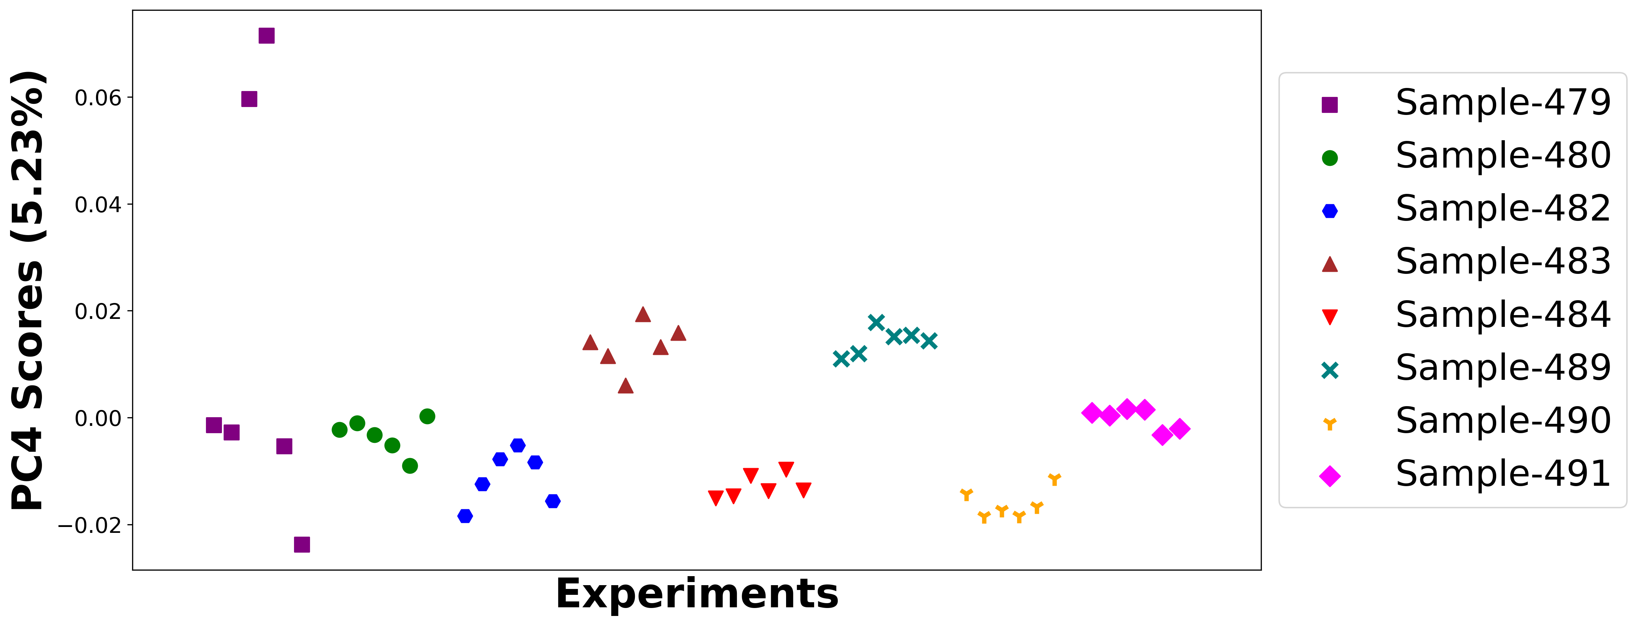

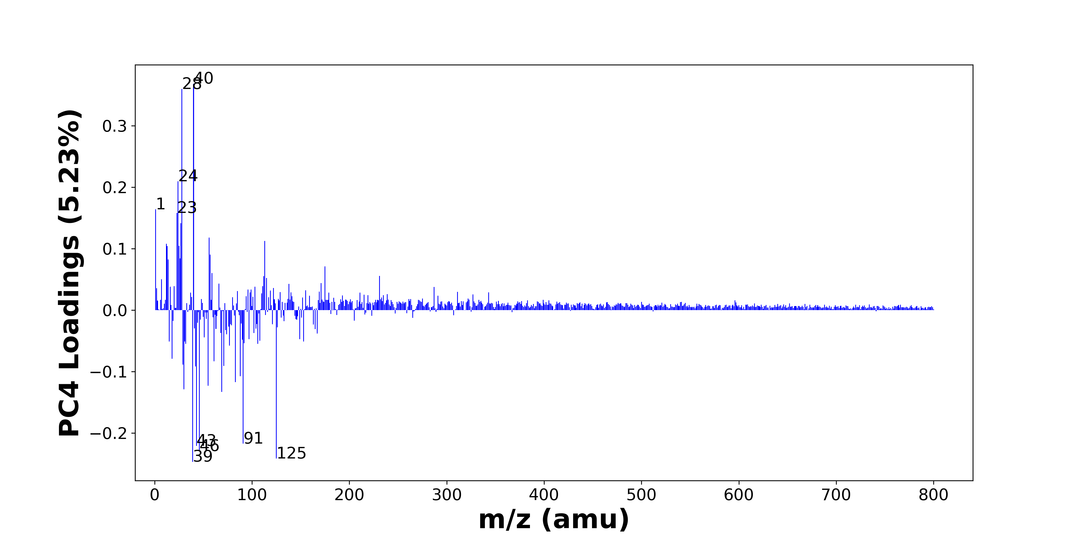

High score samples contain more:

* m/z 40 (Ca+), m/z 28 (Si+), m/z 24 (Mg+), m/z 1 (H+), m/z 23 (Na+), m/z 27 (Al+, C2H3+), m/z 56 (56Fe+), m/z 113 (), m/z 12 (C+), m/z 25 (25Mg+), m/z 13 (), m/z 57 (CaOH+, C4H9+), m/z 26 (26Mg+), m/z 14 (), m/z 175 (Ca2PO4+), m/z 59 (), m/z 231 (Ca3PO5+), m/z 112 (Ca2O2+), m/z 115 (C9H7+, CH5NFe+), m/z 7 (Li+)
* Hydrocarbons

Low score samples contain more:

* m/z 39 (K+), m/z 125 (C8H15N+), m/z 46 (C2H8N+, Na2+), m/z 43 (C2H3O+, C3H7+), m/z 91 (C7H7+), m/z 69 (), m/z 30 (CH4N+, 30Si+), m/z 55 (C4H7+), m/z 83 (C5H9N+), m/z 88 (C4H10NO+), m/z 42 (), m/z 71 (C4H7O+), m/z 29 (C2H5+, 29Si+), m/z 61 (), m/z 18 (NH4+), m/z 77 (C6H5+), m/z 32 (CH6N+), m/z 106 (), m/z 92 (Na2NO2+), m/z 153 ()
* Nitrogen-containing organics, Benzene-containing organics

# Positive ion spectra, top positive loadings -- PC4

|  |  |  |  |  |  |  |  |  |
| --- | --- | --- | --- | --- | --- | --- | --- | --- |
| + Loading No. | Unit Mass | Document Mass | Initial Peak Assignment | Initial Probabilities | Measured Mass | Peak Assignment (Qualified) | Updated Peak Assignment (from Document Mass) | Updated Document Mass |
| 1 | 40 | 39.962 | Ca+ | 1.0 | 39.9625 | Ca+ |  |  |
| 2 | 28 | 27.9764 | Si+ | 1.0 |  |  |  |  |
| 3 | 24 | 23.9845 | Mg+ | 1.0 |  |  |  |  |
| 4 | 1 | 1.0073 | H+ | 1.0 |  |  |  |  |
| 5 | 23 | 22.9892 | Na+ | 1.0 | 22.98 | Na+ |  |  |
| 6 | 27 | 26.981 27.023 | Al+ C2H3+ | 0.702 0.298 |  |  |  |  |
| 7 | 56 | 55.9344 | 56Fe+ | 0.998 |  |  |  |  |
| 8 | 113 |  |  |  |  |  |  |  |
| 9 | 12 | 11.9995 | C+ | 1.0 |  |  |  |  |
| 10 | 25 | 24.9853 | 25Mg+ | 1.0 |  |  |  |  |
| 11 | 13 |  |  |  |  |  |  |  |
| 12 | 57 | 56.9648 57.0699 | CaOH+ C4H9+ | 0.976 0.024 |  |  |  |  |
| 13 | 26 | 25.982 | 26Mg+ | 1.0 |  |  |  |  |
| 14 | 14 |  |  |  |  |  |  |  |
| 15 | 175 | 174.8781 | Ca2PO4+ | 1.0 |  |  |  |  |
| 16 | 59 |  |  |  |  |  |  |  |
| 17 | 231 | 230.8356 | Ca3PO5+ | 1.0 |  |  |  |  |
| 18 | 112 | 111.9145 | Ca2O2+ | 1.0 |  |  |  |  |
| 19 | 115 | 115.0543 114.9174 | C9H7+ CH5NFe+ | 0.877 0.123 |  |  |  |  |
| 20 | 7 | 7.0155 | Li+ | 1.0 |  |  |  |  |

# Positive ion spectra, top negative loadings -- PC4

|  |  |  |  |  |  |  |  |  |
| --- | --- | --- | --- | --- | --- | --- | --- | --- |
| - Loading No. | Unit Mass | Document Mass | Initial Peak Assignment | Initial Probabilities | Measured Mass | Peak Assignment (Qualified) | Updated Peak Assignment (from Document Mass) | Updated Document Mass |
| 1 | 39 | 38.9632 | K+ | 1.0 |  |  |  |  |
| 2 | 125 | 125.1199 | C8H15N+ | 1.0 | 125.13 | C8H15N+ |  |  |
| 3 | 46 | 46.0652 45.979 | C2H8N+ Na2+ | 0.972 0.028 |  |  |  |  |
| 4 | 43 | 43.0178 43.0543 | C2H3O+ C3H7+ | 0.533 0.467 |  |  |  |  |
| 5 | 91 | 91.0543 | C7H7+ | 1.0 |  |  |  |  |
| 6 | 69 |  |  |  |  |  |  |  |
| 7 | 30 | 30.0339 29.9732 | CH4N+ 30Si+ | 0.891 0.109 |  |  |  |  |
| 8 | 55 | 55.0543 | C4H7+ | 1.0 |  |  |  |  |
| 9 | 83 | 83.073 | C5H9N+ | 1.0 | 83.0629 | C5H9N+ |  |  |
| 10 | 88 | 88.0757 | C4H10NO+ | 1.0 |  |  |  |  |
| 11 | 42 |  |  |  |  |  |  |  |
| 12 | 71 | 71.0496 | C4H7O+ | 1.0 |  |  |  |  |
| 13 | 29 | 29.0386 28.9759 | C2H5+ 29Si+ | 0.894 0.106 |  |  |  |  |
| 14 | 61 |  |  |  |  |  |  |  |
| 15 | 18 | 18.0339 | NH4+ | 1.0 |  |  |  |  |
| 16 | 77 | 77.0386 | C6H5+ | 1.0 |  |  |  |  |
| 17 | 32 | 32.0645 | CH6N+ | 1.0 | 32.0595 | CH6N+ |  |  |
| 18 | 106 |  |  |  |  |  |  |  |
| 19 | 92 | 91.9719 | Na2NO2+ | 1.0 |  |  |  |  |
| 20 | 153 |  |  |  |  |  |  |  |

# Positive ion spectra, molecular information from PC4 loadings plot

* The major positive PC4 loadings are m/z 40 (Ca+), m/z 28 (Si+), m/z 24 (Mg+), m/z 1 (H+), m/z 23 (Na+), m/z 27 (Al+, C2H3+), m/z 56 (56Fe+), m/z 113 (), m/z 12 (C+), m/z 25 (25Mg+), m/z 13 (), m/z 57 (CaOH+, C4H9+), m/z 26 (26Mg+), m/z 14 (), m/z 175 (Ca2PO4+), m/z 59 (), m/z 231 (Ca3PO5+), m/z 112 (Ca2O2+), m/z 115 (C9H7+, CH5NFe+), m/z 7 (Li+), indicating they are more observed in high PC4 score samples.
* The major negative PC4 loadings are m/z 39 (K+), m/z 125 (C8H15N+), m/z 46 (C2H8N+, Na2+), m/z 43 (C2H3O+, C3H7+), m/z 91 (C7H7+), m/z 69 (), m/z 30 (CH4N+, 30Si+), m/z 55 (C4H7+), m/z 83 (C5H9N+), m/z 88 (C4H10NO+), m/z 42 (), m/z 71 (C4H7O+), m/z 29 (C2H5+, 29Si+), m/z 61 (), m/z 18 (NH4+), m/z 77 (C6H5+), m/z 32 (CH6N+), m/z 106 (), m/z 92 (Na2NO2+), m/z 153 (), indicating they are more observed in low PC4 score samples.
* Hydrocarbons signals, such as m/z 27 (Al+, C2H3+), m/z 57 (CaOH+, C4H9+), are mostly found in positive loadings, indicating that high PC4 score samples contain more Hydrocarbons.
* Nitrogen-containing organics signals, such as m/z 30 (CH4N+, 30Si+), m/z 18 (NH4+), are mostly found in negative loadings, indicating that low PC4 score samples contain more Nitrogen-containing organics.
* Benzene-containing organics signals, such as m/z 91 (C7H7+), m/z 77 (C6H5+), are mostly found in negative loadings, indicating that low PC4 score samples contain more Benzene-containing organics.

# Positive ion spectra, PCA analysis results -- PC5

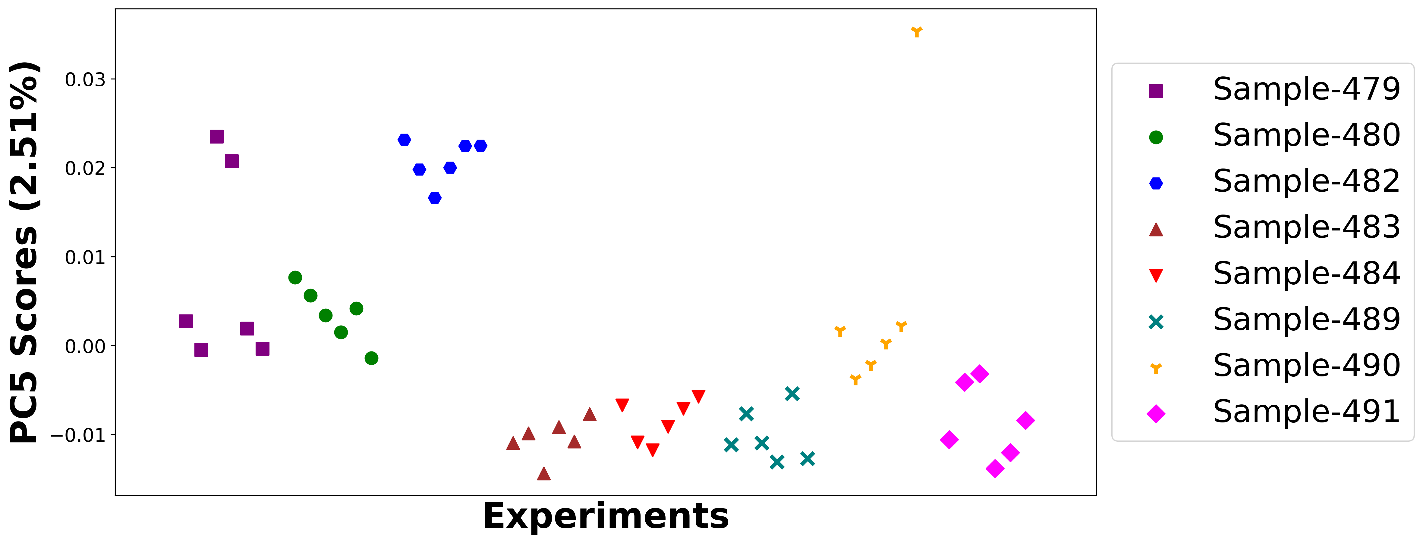

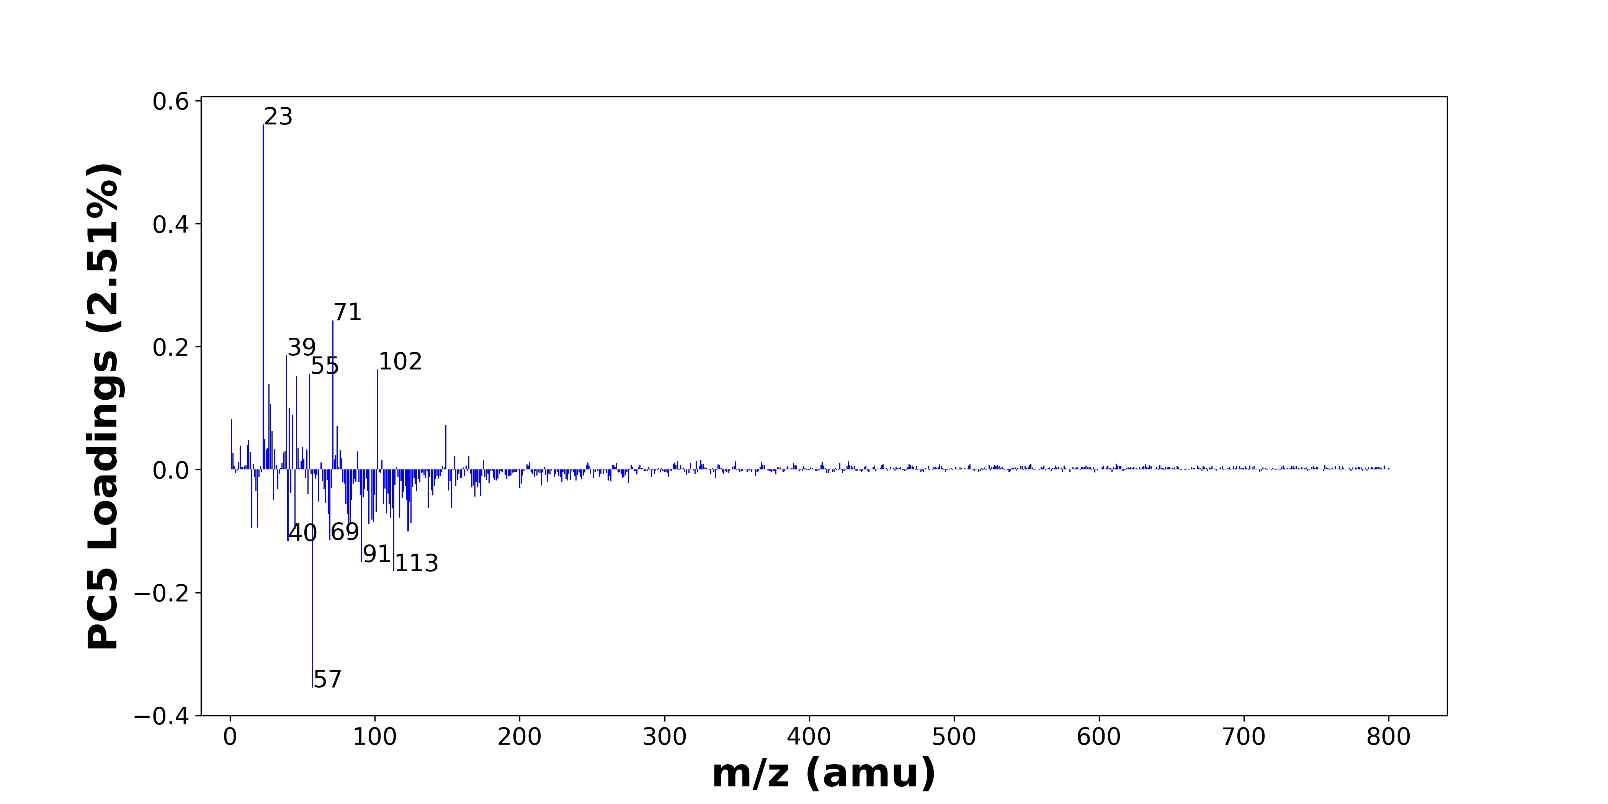

High score samples contain more:

* m/z 23 (Na+), m/z 71 (C4H7O+), m/z 39 (K+), m/z 102 (), m/z 55 (C4H7+), m/z 46 (C2H8N+, Na2+), m/z 27 (Al+, C2H3+), m/z 28 (Si+), m/z 41 (C3H5+, 41K+), m/z 43 (C2H3O+, C3H7+), m/z 1 (H+), m/z 149 (), m/z 74 (), m/z 29 (C2H5+, 29Si+), m/z 24 (Mg+), m/z 13 (), m/z 12 (C+), m/z 7 (Li+), m/z 50 (), m/z 26 (26Mg+)
* Hydrocarbons

Low score samples contain more:

* m/z 57 (CaOH+, C4H9+), m/z 113 (), m/z 91 (C7H7+), m/z 40 (Ca+), m/z 69 (), m/z 82 (), m/z 123 (), m/z 45 (SiOH+, C2H5O+), m/z 15 (CH3+), m/z 19 (OH3+), m/z 83 (C5H9N+), m/z 96 (), m/z 125 (C8H15N+), m/z 99 (H3SO4+), m/z 98 (), m/z 117 (), m/z 111 (?CH3SO4+), m/z 68 (), m/z 81 (), m/z 108 (Na2NO3+)
* Benzene-containing organics

# Positive ion spectra, top positive loadings -- PC5

|  |  |  |  |  |  |  |  |  |
| --- | --- | --- | --- | --- | --- | --- | --- | --- |
| + Loading No. | Unit Mass | Document Mass | Initial Peak Assignment | Initial Probabilities | Measured Mass | Peak Assignment (Qualified) | Updated Peak Assignment (from Document Mass) | Updated Document Mass |
| 1 | 23 | 22.9892 | Na+ | 1.0 | 22.98 | Na+ |  |  |
| 2 | 71 | 71.0496 | C4H7O+ | 1.0 |  |  |  |  |
| 3 | 39 | 38.9632 | K+ | 1.0 |  |  |  |  |
| 4 | 102 |  |  |  |  |  |  |  |
| 5 | 55 | 55.0543 | C4H7+ | 1.0 |  |  |  |  |
| 6 | 46 | 46.0652 45.979 | C2H8N+ Na2+ | 0.972 0.028 |  |  |  |  |
| 7 | 27 | 26.981 27.023 | Al+ C2H3+ | 0.702 0.298 |  |  |  |  |
| 8 | 28 | 27.9764 | Si+ | 1.0 |  |  |  |  |
| 9 | 41 | 41.0386 40.9613 | C3H5+ 41K+ | 0.927 0.073 |  |  |  |  |
| 10 | 43 | 43.0178 43.0543 | C2H3O+ C3H7+ | 0.533 0.467 |  |  |  |  |
| 11 | 1 | 1.0073 | H+ | 1.0 |  |  |  |  |
| 12 | 149 |  |  |  |  |  |  |  |
| 13 | 74 |  |  |  |  |  |  |  |
| 14 | 29 | 29.0386 28.9759 | C2H5+ 29Si+ | 0.894 0.106 |  |  |  |  |
| 15 | 24 | 23.9845 | Mg+ | 1.0 |  |  |  |  |
| 16 | 13 |  |  |  |  |  |  |  |
| 17 | 12 | 11.9995 | C+ | 1.0 |  |  |  |  |
| 18 | 7 | 7.0155 | Li+ | 1.0 |  |  |  |  |
| 19 | 50 |  |  |  |  |  |  |  |
| 20 | 26 | 25.982 | 26Mg+ | 1.0 |  |  |  |  |

# Positive ion spectra, top negative loadings -- PC5

|  |  |  |  |  |  |  |  |  |
| --- | --- | --- | --- | --- | --- | --- | --- | --- |
| - Loading No. | Unit Mass | Document Mass | Initial Peak Assignment | Initial Probabilities | Measured Mass | Peak Assignment (Qualified) | Updated Peak Assignment (from Document Mass) | Updated Document Mass |
| 1 | 57 | 56.9648 57.0699 | CaOH+ C4H9+ | 0.976 0.024 |  |  |  |  |
| 2 | 113 |  |  |  |  |  |  |  |
| 3 | 91 | 91.0543 | C7H7+ | 1.0 |  |  |  |  |
| 4 | 40 | 39.962 | Ca+ | 1.0 | 39.9625 | Ca+ |  |  |
| 5 | 69 |  |  |  |  |  |  |  |
| 6 | 82 |  |  |  |  |  |  |  |
| 7 | 123 |  |  |  |  |  |  |  |
| 8 | 45 | 44.9792 45.0335 | SiOH+ C2H5O+ | 0.761 0.239 |  |  |  |  |
| 9 | 15 | 15.023 | CH3+ | 1.0 |  |  |  |  |
| 10 | 19 | 19.0179 | OH3+ | 1.0 |  |  |  |  |
| 11 | 83 | 83.073 | C5H9N+ | 1.0 | 83.0629 | C5H9N+ |  |  |
| 12 | 96 |  |  |  |  |  |  |  |
| 13 | 125 | 125.1199 | C8H15N+ | 1.0 | 125.13 | C8H15N+ |  |  |
| 14 | 99 | 98.9747 | H3SO4+ | 1.0 |  |  |  |  |
| 15 | 98 |  |  |  |  |  |  |  |
| 16 | 117 |  |  |  |  |  |  |  |
| 17 | 111 | 110.9747 | ?CH3SO4+ | 1.0 | 110.97 | ?CH3SO4+ |  |  |
| 18 | 68 |  |  |  |  |  |  |  |
| 19 | 81 |  |  |  |  |  |  |  |
| 20 | 108 | 107.9669 | Na2NO3+ | 1.0 |  |  |  |  |

# Positive ion spectra, molecular information from PC5 loadings plot

* The major positive PC5 loadings are m/z 23 (Na+), m/z 71 (C4H7O+), m/z 39 (K+), m/z 102 (), m/z 55 (C4H7+), m/z 46 (C2H8N+, Na2+), m/z 27 (Al+, C2H3+), m/z 28 (Si+), m/z 41 (C3H5+, 41K+), m/z 43 (C2H3O+, C3H7+), m/z 1 (H+), m/z 149 (), m/z 74 (), m/z 29 (C2H5+, 29Si+), m/z 24 (Mg+), m/z 13 (), m/z 12 (C+), m/z 7 (Li+), m/z 50 (), m/z 26 (26Mg+), indicating they are more observed in high PC5 score samples.
* The major negative PC5 loadings are m/z 57 (CaOH+, C4H9+), m/z 113 (), m/z 91 (C7H7+), m/z 40 (Ca+), m/z 69 (), m/z 82 (), m/z 123 (), m/z 45 (SiOH+, C2H5O+), m/z 15 (CH3+), m/z 19 (OH3+), m/z 83 (C5H9N+), m/z 96 (), m/z 125 (C8H15N+), m/z 99 (H3SO4+), m/z 98 (), m/z 117 (), m/z 111 (?CH3SO4+), m/z 68 (), m/z 81 (), m/z 108 (Na2NO3+), indicating they are more observed in low PC5 score samples.
* Hydrocarbons signals, such as m/z 27 (Al+, C2H3+), m/z 29 (C2H5+, 29Si+), m/z 41 (C3H5+, 41K+), m/z 43 (C2H3O+, C3H7+), m/z 55 (C4H7+), are mostly found in positive loadings, indicating that high PC5 score samples contain more Hydrocarbons.
* Benzene-containing organics signals, such as m/z 91 (C7H7+), are mostly found in negative loadings, indicating that low PC5 score samples contain more Benzene-containing organics.